Day 8 - 05th June 2025

Enum , gettters and setters (encapsulation), Arrays, (pending from yesterday)
OOP's concepts Inheritance, Polymorphism, Encapsulation, Abstraction, Interfaces, Exception Handling,
Enums
//Attaching Multiple values
public enum Element {
H("Hydrogen", 1, 1.008f),
HE("Helium", 2, 4.0026f),
// ...
NE("Neon", 10, 20.180f);

private static final Map<String, Element> BY_LABEL = new HashMap<>();
private static final Map<Integer, Element> BY_ATOMIC_NUMBER = new HashMap<>();
private static final Map<Float, Element> BY_ATOMIC_WEIGHT = new HashMap<>();

static {
for (Element e : values()) { //for each loop
BY_LABEL.put(e.label, e);
BY_ATOMIC_NUMBER.put(e.atomicNumber, e);
BY_ATOMIC_WEIGHT.put(e.atomicWeight, e);
}
}
public final String label;
public final int atomicNumber;
public final float atomicWeight;

private Element(String label, int atomicNumber, float atomicWeight) {
this.label = label;
this.atomicNumber = atomicNumber;
this.atomicWeight = atomicWeight;
}

public static Element valueOfLabel(String label) {
return BY_LABEL.get(label);
}

public static Element valueOfAtomicNumber(int number) {
return BY_ATOMIC_NUMBER.get(number);
}

public static Element valueOfAtomicWeight(float weight) {
return BY_ATOMIC_WEIGHT.get(weight)
}
}

Task 19:

Wap to display the content of the above enum.. (main needs to be added)
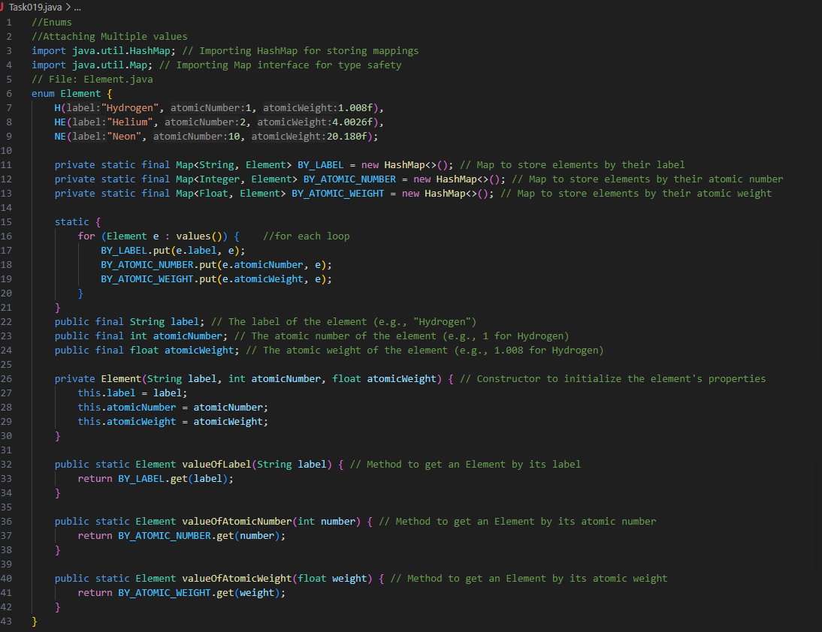
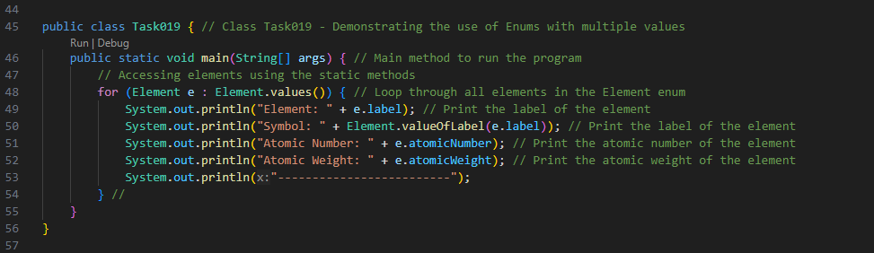
Output:
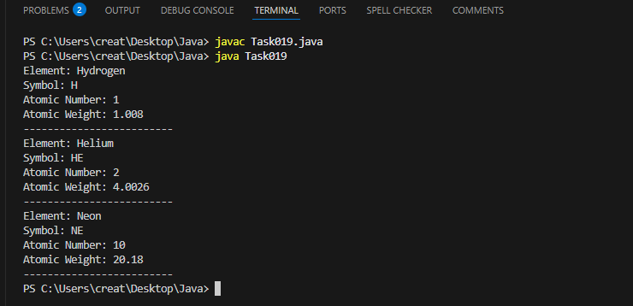
==================================================================

Code from yesterday
================================================================

Task 017:
Getter and setter
Create a program name Person.java

public class Person {
private String name;

// Getter
public String getName() {
return name;
}

// Setter
public void setName(String newName) {
this.name = newName;
}
}
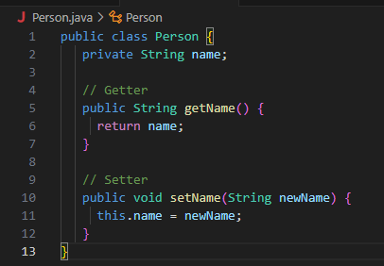
Create another program named Task017.java

public class Task017{
public static void main(String[] args) {
Person myObj = new Person();
myObj.name = "John";
System.out.println(myObj.name);
}
}

Output:
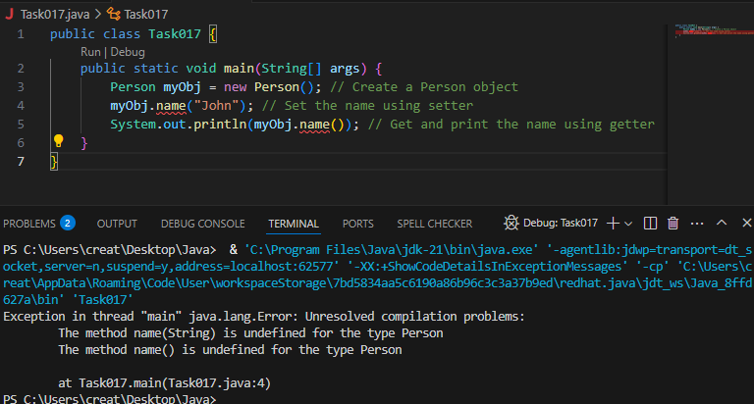

—----------------------------------what is the reason for the error —---------------explain
Error because the method calls name("John") and name() do not exist in the Person class. Java does not automatically create setter and getter methods for attributes unless explicitly defined

Task 018:
Now create one more program named Task018.java
public class Main {
public static void main(String[] args) {
Person myObj = new Person();
myObj.setName("John");
System.out.println(myObj.getName());
}
}
Output:
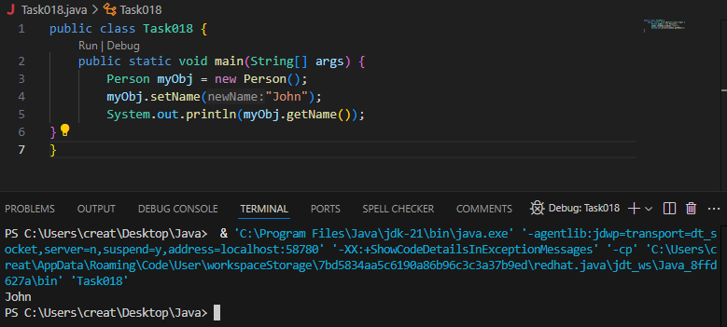

======================================================================
4444444444444444444444$$$$$$$$$$$$$$$$$$$$$$$$$$$$$$$$$444444444444444444======================================================================

Arrays
Task 020:
Create an array of your name
Hint : use
Char[] Name = {‘P’, “r’, ….}; // initializing an array
sout(Name);
Int n = Name.length; // size of your name
sout(“there are “+ n +”letters in my name”);
Use for loop to display each letter..
Output:
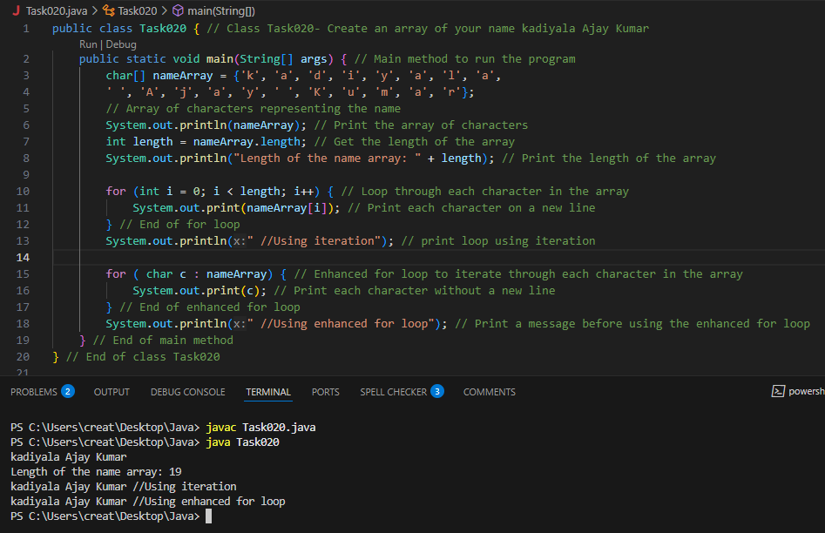

sHALLOW copy and Deep copy

Copy Type | Description | Example
Shallow Copy | Both arrays share references to the same objects | Shallow Copied Array : [[obj1, obj2] , [obj3], [obj4]]
Deep Copy | New instances of objects are created. | Deep copied array : [[newObj1, newObj2] , [newObj3], [newObj4]]

+++++++++++++++++++++++++++++++++++++++++=============++++++++++++++++
Task 21 to Task 30 – home tasks
+++++++++++++++++++++++++++++++++++++++++++++++++++++++++++++++++++++
Task 21:
initialize an array and traverse it using a for loop to print each element.
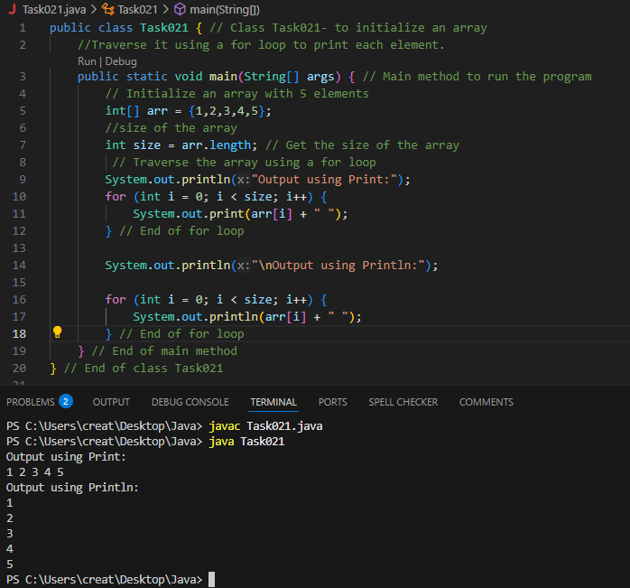
Task022:

Implementation:
// Java program to illustrate creating an array
// of integers, puts some values in the array,
// and prints each value to standard output.
​
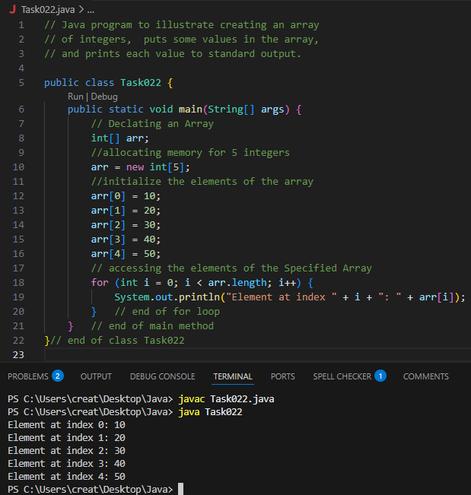
Task023:
Here we are taking a student class and creating an array of Student with five Student objects stored in the array. The Student objects have to be instantiated using the constructor of the Student class, and their references should be assigned to the array elements.
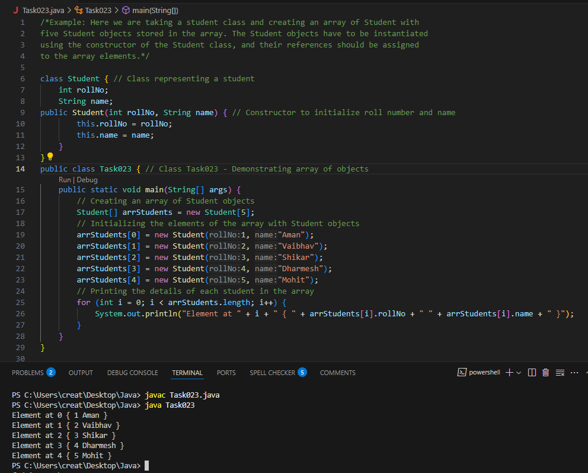
Task24:
Example: An array of objects is also created like
// Java program to illustrate creating
// an array of objects
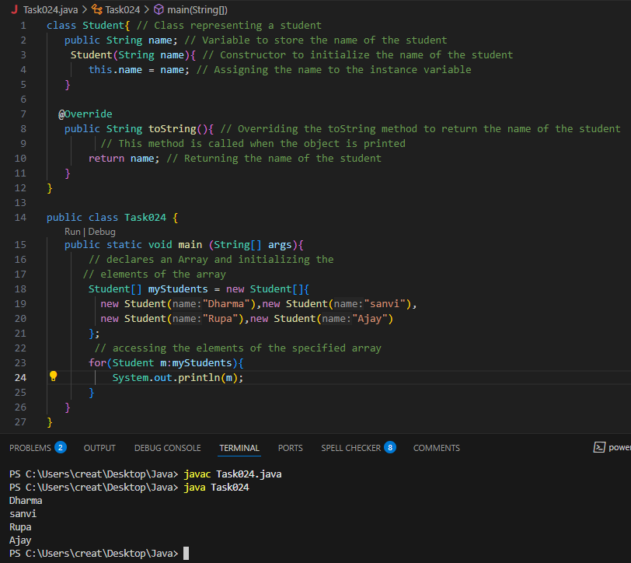
Task:25
// Code for showing error "ArrayIndexOutOfBoundsException"
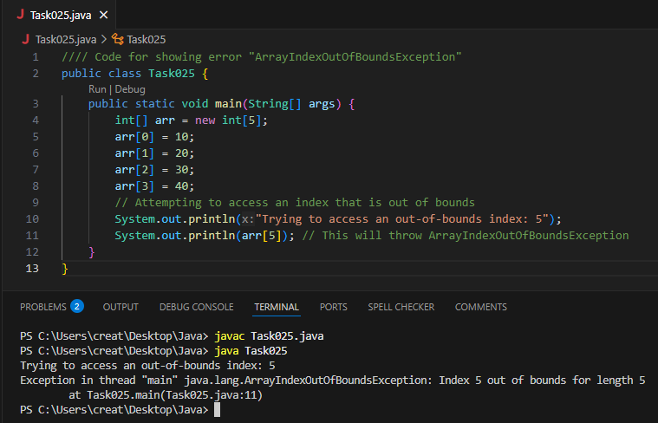
Task26:
Example: Let us start with basic two dimensional Array declared and initialized
// Java Program to demonstrate
// Multidimensional Array
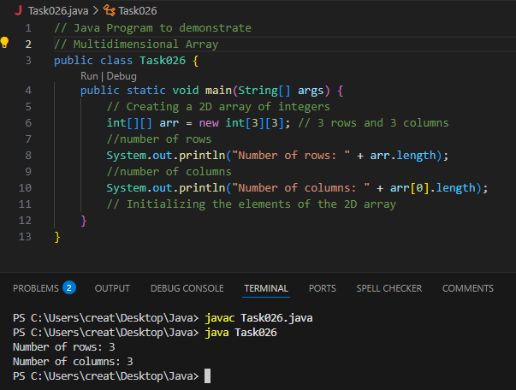

Task026_1:
declaring and initializing the array
Traverse the Multidimensional Array using for loop.
/int arr[][] = { { 2, 7, 9 }, { 3, 6, 1 }, { 7, 4, 2 } };
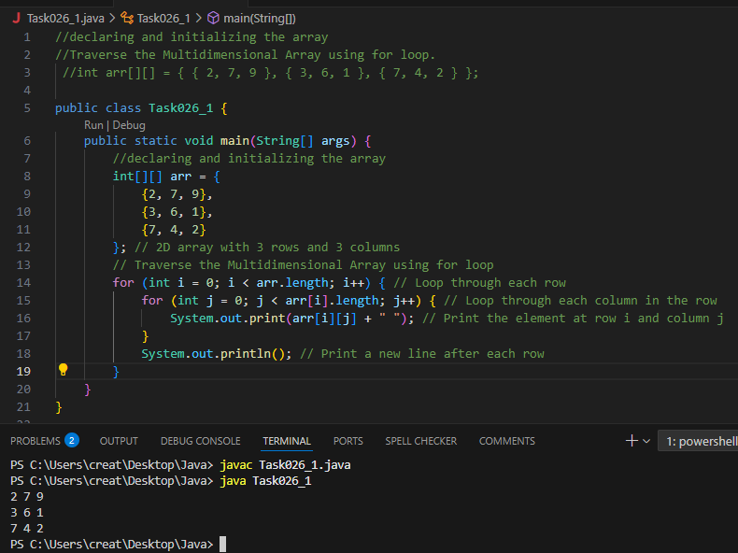

Passing Arrays to Methods:
Task027:
// Java program to demonstrate
// passing of array to method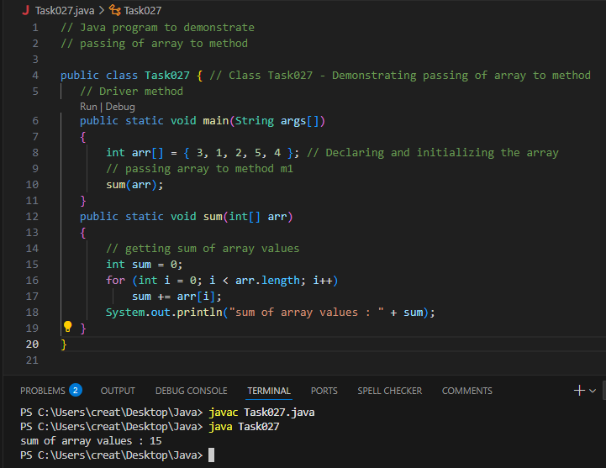

Task028:
A method can also return an array. For example, the below program returns an array from method m1.

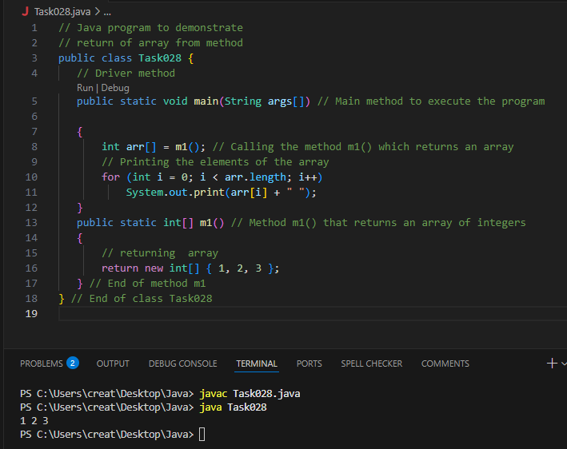

Task029:
// Java program to demonstrate
// cloning of one-dimensional arrays
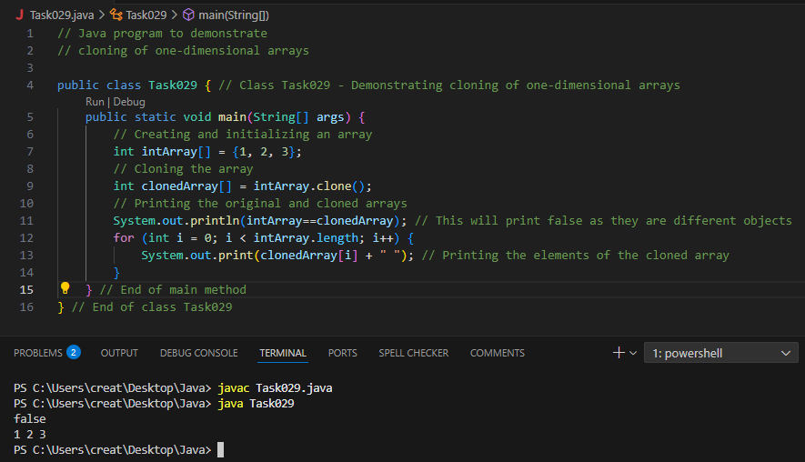

Cloning Multidimensional Array:
Task030:

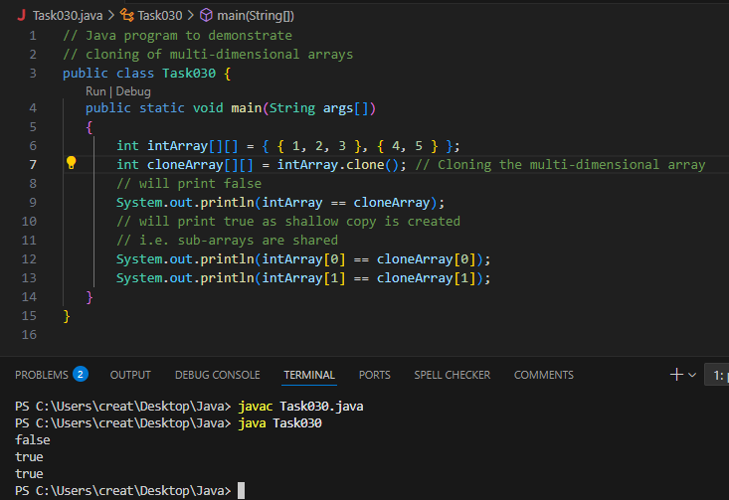

=========================================++++++++++++++++++++++++++++
OOPS (Object Oriented Programming) ++++++++++++++++++++++++++++++++++++++++++==============================

Inheritance, Polymorphism, Encapsulation, Abstraction, Interfaces, Exception Handling,

4 pillers of OOPS
Inheritance, Polymorphism, Encapsulation, Abstraction

Inheritance : getting parental characteristics

Types of inheritance

Single inheritance
Multi level inheritance
hYBRID IN
Hyrarical inhe

Multiple Inheritance — not supported in java
Due to diamond problem

Task 031

class Calculation {
int z;

public void addition(int x, int y) {
z = x + y;
System.out.println("The sum of the given numbers:"+z);
}

public void Subtraction(int x, int y) {
z = x - y;
System.out.println("The difference between the given numbers:"+z);
}
}

public class My_Calculation extends Calculation {
public void multiplication(int x, int y) {
z = x * y;
System.out.println("The product of the given numbers:"+z);
}

public static void main(String args[]) {
int a = 20, b = 10;
My_Calculation demo = new My_Calculation();
demo.addition(a, b);
demo.Subtraction(a, b);
demo.multiplication(a, b);
}
}
Output:
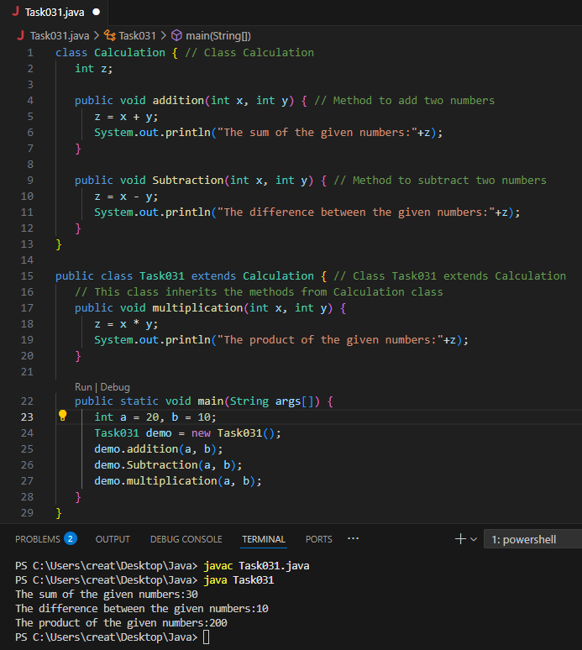
Inheritance provides - reusability

It avoids - duplication

—--Task 032 ------------------------------------------------------------------------------

In the above code add a class clock — and try to extend calculation and clock in my calculation class.. Is it possible ???? give a reason.

class clock {
—--
}
class my_calculation extends calculation , clock{ // multiple inheritance

// —---------------------------------- ???????????????????????

}
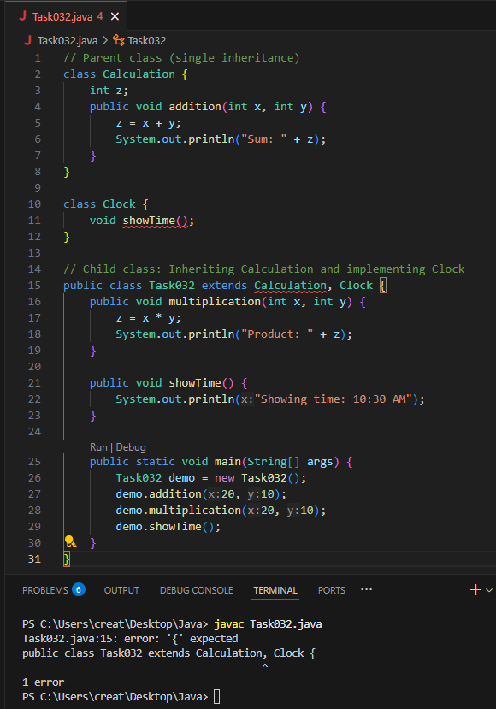
No, it is not possible to extend both Calculation and Clock using class My_Calculation extends Calculation, Clock{} because Java does not support multiple inheritance with classes.
Reason:
- In Java, a class cannot inherit from multiple classes (extends Class1, Class2).
- This is because multiple inheritance can cause ambiguity if both parent classes (Calculation and Clock) have the same method names.
Task033:
Task 033
—-----------------------------------------------------------------

class Customer {

Void purchage_list{
Int cos = 40t;
String items = “Tomatoes”;
}
}

public class Mart extends Customer {
Void billing(){
String items = “onions”;
Int cost = 30;
}
Psvm (String[] args) {
Super.items = “Potatoes”
Super.cost = 50;

Sout(items);
sout(cost);
sout”(%%%%%%%%%%%%%%”);
Sout(super.items);
sout(suer.cost);
}
}
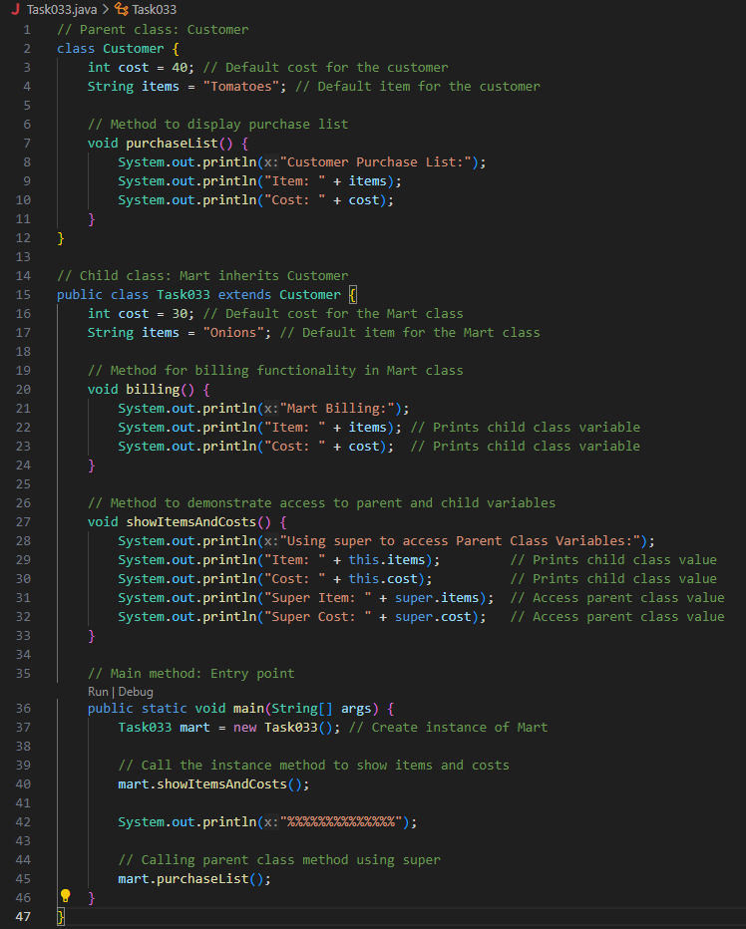
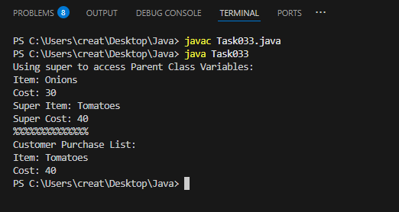

Polymorphism – Method overloading
---------------------------------------------------------------------------------------------------------------------------

Two or more methods having the same name but differ -

No of parameters
Type of parameters
Sequence of parameters

Task034:
No of parameters:

Void add(int x, int y){
Sout —> x and y values
}
Void add(int x, int y, int z){
Sout —-> x, y, z values

}
psvm(){
add(10,20,30);
add(50,100);
}
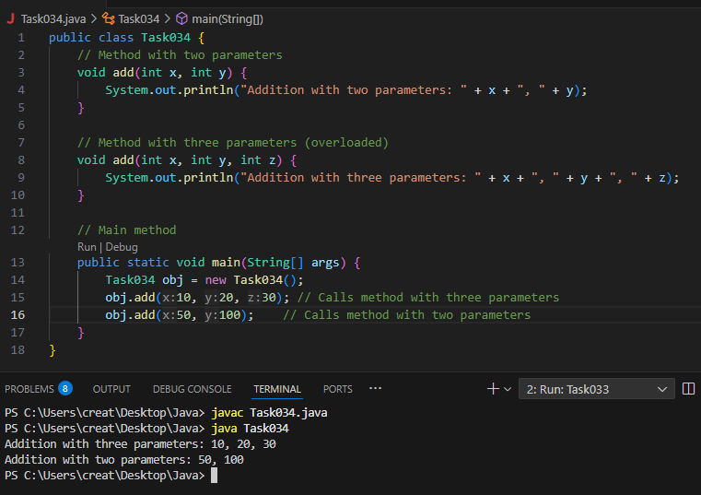

Task035:
Type of parameters:

Void add(char x, char y){
Sout —-> x, y values
}

Void add(int x, int y) {
Sout —> x, y values
}

psvm(){
add(‘d’, ‘a’);
add(100, 100);
}
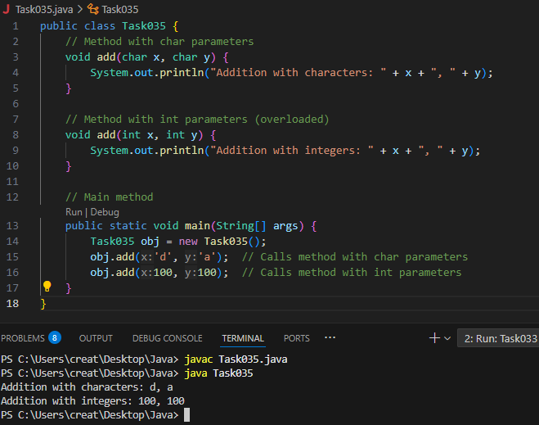

Task036:

Sequence of Parameters:

Void add(int x, float y){
Sout → x, y values
}
Void add(float x, int y){
Sout → x, y
}
psvm(){
add(10.50f, 60);
add(100, 80.80f)
}
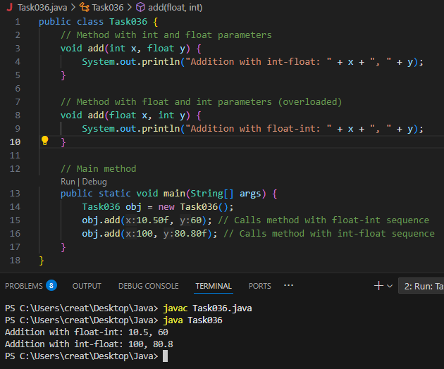

======================================================================
Encapsulation
======================================================================

Data hiding – secured data
Access modifiers 👍
private
Protected – inheritance
Public – anyone can access

Task 037:

Class Employee{
Private int pwd;
Protected int Salary;
Public int empid:

employee(){ // constructors are methods having same name as class name (we have in c++)
}
~employee(){// destructors used in c++ but not in java
}

}
Class Hr extends Employee {
super.pwd = 1254; //===============> ??????
super.Salary = 50000; //==================> ?
Super.empid = 10001; // ======================>?
psvm(){
}
}
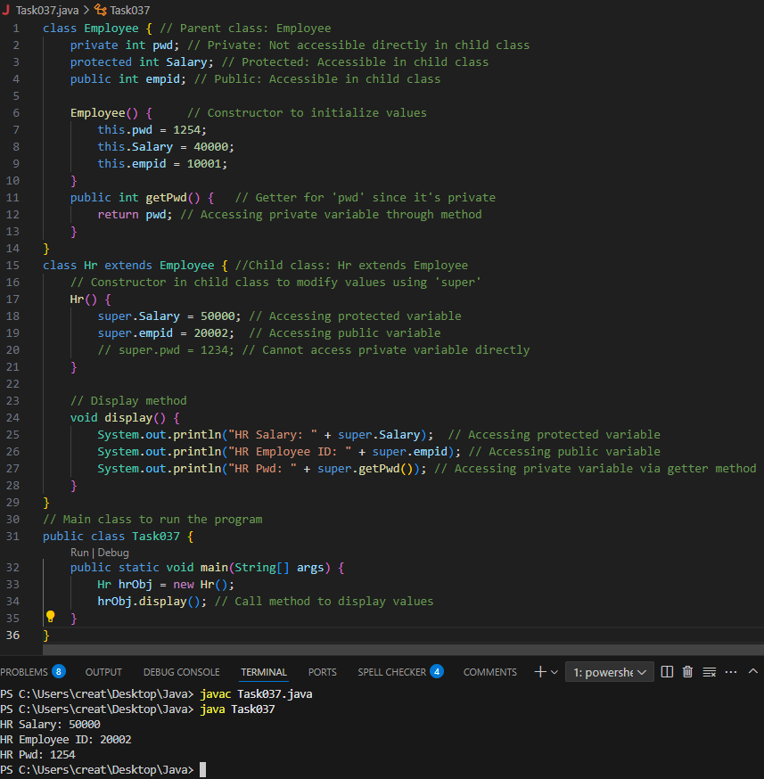
======================================================================
Abstraction ======================================================================

Java Abstract Classes

A Java class which contains the abstract keyword in its declaration is known as abstract class.

Java abstract classes may or may not contain abstract methods, i.e., methods without body ( public void get(); )

But, if a class has at least one abstract method, then the class must be declared abstract.

If a class is declared abstract, it cannot be instantiated.

To use an abstract class, you have to inherit it from another class, provide implementations to the abstract methods in it.

If you inherit an abstract class, you have to provide implementations to all the abstract methods in it.

Task 038

/* File name : AbstractDemo.java */
Public class AbstractDemo {

public static void main(String [] args) {
/* Following is not allowed and would raise error */
Employee e = new Employee("George W.", "Houston, TX", 43);
System.out.println("\n Call mailCheck using Employee reference--");
e.mailCheck();
}
}

abstract class Employee {
private String name;
private String address;
private int number;

public Employee(String name, String address, int number) {
System.out.println("Constructing an Employee");
this.name = name;
this.address = address;
this.number = number;
}

public double computePay() {
System.out.println("Inside Employee computePay");
return 0.0;
}

public void mailCheck() {
System.out.println("Mailing a check to " + this.name + " " + this.address);
}

public String toString() {
return name + " " + address + " " + number;
}

public String getName() {
return name;
}

public String getAddress() {
return address;
}

public void setAddress(String newAddress) {
address = newAddress;
}

public int getNumber() {
return number;
}
}
Output:
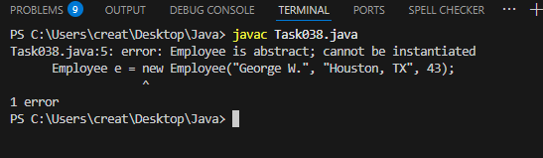

Task 039

Rewrite the above code to give the output without errors..
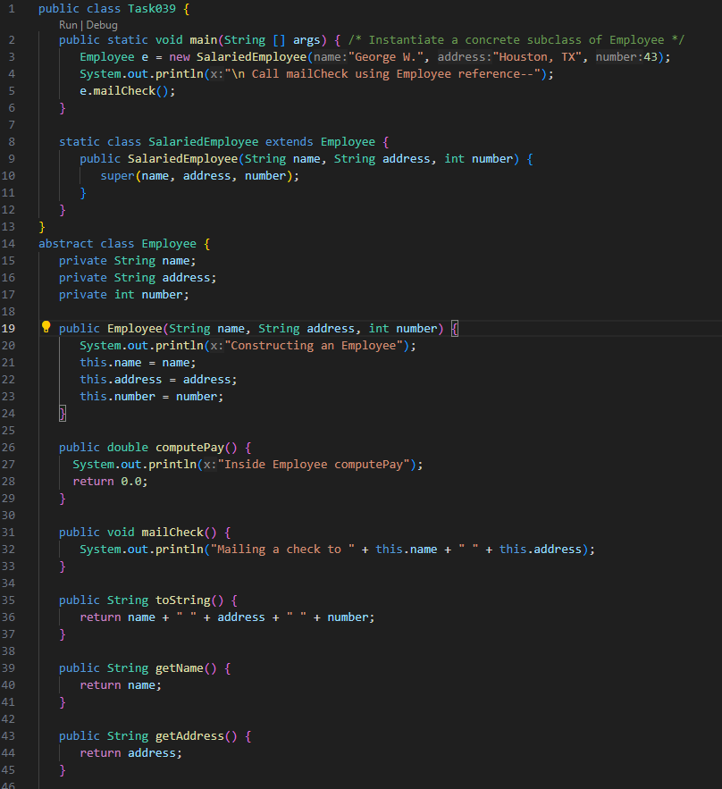
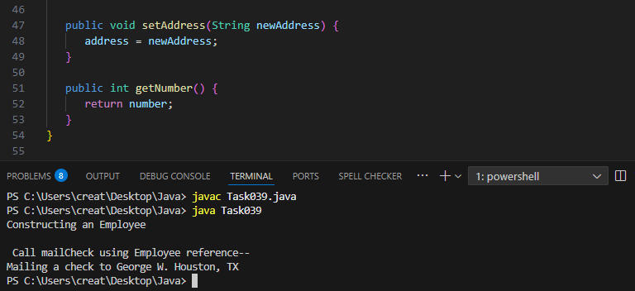
Task040:
// Working of Abstraction in Java
abstract class Gadgets {
abstract void turnOn();
abstract void turnOff();
}
// Concrete class implementing the abstract methods
class TVRemote extends Gadgets {
@Override
void turnOn() {
System.out.println("TV is turned ON.");
}

@Override
void turnOff() {
System.out.println("TV is turned OFF.");
}
}
class ACRemote extends Gadgets {
@Override
void turnOn() {
System.out.println("AC is turned ON.");
}

@Override
void turnOff() {
System.out.println("AC is turned OFF.");
}
}

// Main class to demonstrate abstraction
public class Main {
public static void main(String[] args) {
Gadgets remote = new TVRemote();
Gadgets remote = new ACRemote();
remote.turnOn();
remote.turnOff();

Gadgets remote = new FanRemote();
Gadgets remote = new CoolerRemote();
remote.turnOn();
remote.turnOff();
}
}
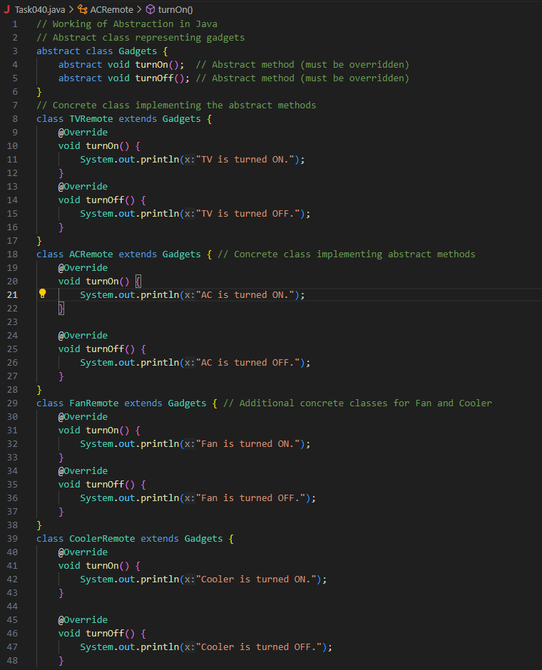
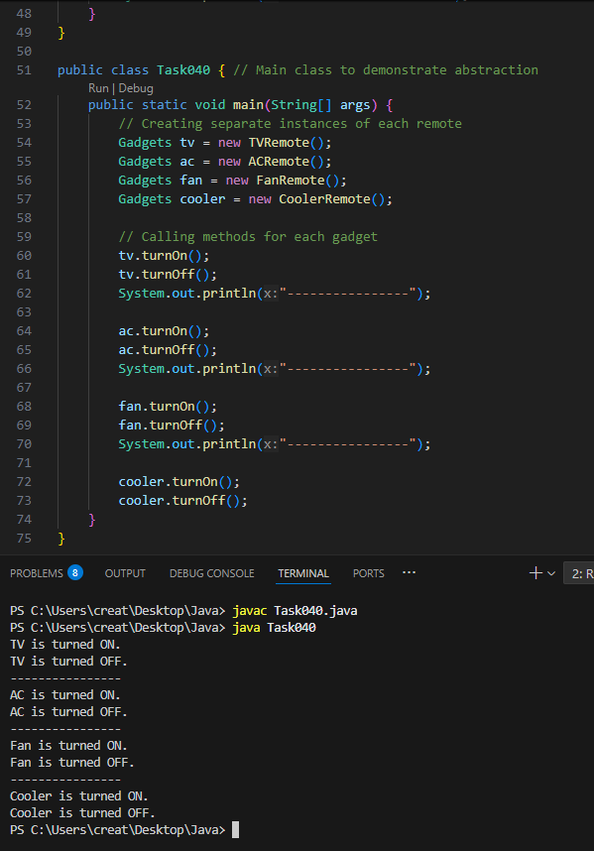

======================================================================
Interfaces in java
======================================================================

An Interface in Java programming language is defined as an abstract type used to specify the behaviour of a class. An interface in Java is a blueprint of a behaviour. A Java interface contains static constants and abstract methods.
Key Properties of Interface:
- The interface in Java is a mechanism to achieve abstraction.
- By default, variables in an interface are public, static, and final.
- It is used to achieve abstraction and multiple inheritance in Java.
- It supports loose coupling (classes depend on behavior, not implementation).
- In other words, interfaces primarily define methods that other classes must implement.
- An interface in Java defines a set of behaviours that a class can implement, usually representing an IS-A relationship, but not always in every scenario.
Task 041
import java.io.*;
// Interface Declared
//Driver Code Ends
interface testInterface {

// public, static and final
final int a = 10;
// public and abstract
void display();
}
// Class implementing interface
class TestClass implements testInterface {
// Implementing the capabilities of
// Interface
public void display(){
System.out.println("Myclass");
}
}
class Myclass
//Driver Code Starts
{
public static void main(String[] args)
{
TestClass t = new TestClass();
t.display();
System.out.println(t.a);
}
}
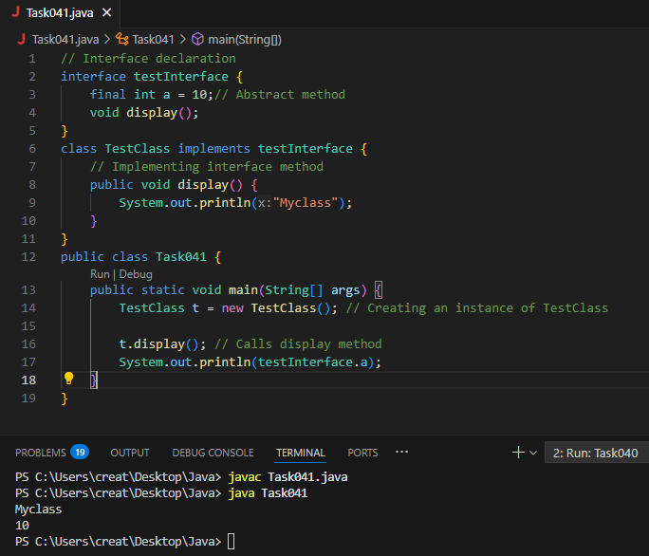
Task 041:
Difference between Final and constant
In Java, the concept of a "constant" is implemented using the final keyword. While final is the tool, the term "constant" refers to the idea of an unchangeable value. Here's a breakdown:
Final Keyword
- Purpose:
The final keyword in Java is a non-access modifier that indicates that a variable, method, or class cannot be modified after its initial definition.
- Variables:
When applied to a variable, final makes it a constant. Its value must be assigned at the time of declaration or within the constructor for instance variables. Once assigned, the value cannot be changed.
- Methods:
A final method cannot be overridden by subclasses, ensuring its behavior remains consistent.
- Classes:
A final class cannot be subclassed, preventing inheritance.
Constants
- Concept:
A constant is a variable whose value is fixed and cannot be changed after initialization. Constants are used to represent values that should not be modified during the program's execution.
- Implementation:
In Java, constants are created using the final keyword. It's common practice to declare constants as public static final, making them accessible from anywhere and ensuring they have a single copy throughout the program.
- Compile-Time vs. Run-Time:
  - final variables can be initialized at compile-time or run-time.
  - When final variables are initialized with literal values or constant expressions at compile-time, they behave as true constants.
  - When final variables are initialized at run-time, they become run-time constants, meaning their value is fixed after their first assignment but not known until the program runs.

Key Differences
- Terminology:
"Constant" is a conceptual idea, while final is the Java keyword to realize that idea.
- Flexibility:
final variables can be initialized at run-time, allowing for values that are not known at compile time.
- Scope:
final can be applied to variables, methods, and classes, while "constant" is primarily associated with variables.
In summary, final is the mechanism to create constants in Java. By declaring a variable as final, you ensure its value remains unchanged, promoting code clarity and preventing accidental modifications.
============================================================================================================

